COMPLIANCE DECLARATIONS TEMPLATE – TO BE COMPLETED BY CLIENT. THE CLIENT MUST ALSO OBTAIN WRITTEN AND SIGNED STATEMENTS FROM OTHERS INVOLVED IN YOUR PROJECT / BUILDING WORK.
PLEASE NOTE WE CANNOT LAWFULLY RELEASE A FINAL / COMPLETION CERTIFICATE UNTIL STATEMENTS ARE OBTAINED AND SUBMITTED TO BUILDING CONTROL
RETURN COMPLETED FORM TO OUR OFFICES via email : support@bcsurv.com

DUTY IN LAW UNDER REGULATION 16E
CLIENT TO COMPLETE
The Building (Approved Inspectors etc. and Review of Decisions) (England) Regulations 2023
Regulation 16E. Where building work described in an initial notice is completed the client must give
the approved inspector a notice which includes—
- (a) the name, address, telephone number and (if available) email address of the client;

- (b) the name, address, telephone number and (if available) email address of the principal contractor (or sole contractor) and the principal designer (or sole or lead designer);

- (c) a statement that the building work is complete;

- (d) a statement, signed by the client, confirming that to the best of the client’s knowledge the work complies with all applicable requirements of the building regulations;
As the client I confirm that to the best of my knowledge that the work carried out at {enter address}
Building Control Ref. No : __________
Description of work shown on Initial Notice : __________

Complies with all the applicable requirements* of the building regulations.

*= “Applicable Requirements” means are those requirements contained within schedule 1 of the Building Regulations 2010 (as amended).

- (e) Submit a statement/s given by each principal contractor (or sole contractor) for the work and each principal designer (or sole or lead designer) for the work, signed by the person to which the declaration relates, which includes—
(i) the name, address, telephone number and (if available) email address of that person;
(ii) the dates of their appointment, and
(iii) confirmation—
(aa) in the case of a principal contractor (or sole contractor), that they fulfilled their duties as a principal contractor under Part 2A (dutyholders and competence) of the Principal Regulations;

(bb) in the case of a principal designer (or sole or lead designer), that they fulfilled their duties as a principal designer under Part 2A (dutyholders and competence) of the Principal Regulations.”.

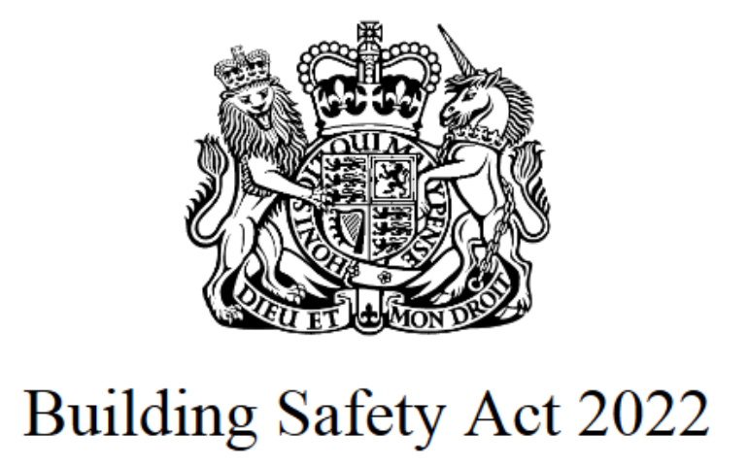

Once all of the information has been gathered please forward this form together with your compiled statements back to our building control office, where the data will be validated and stored.

Please note that the data will be confidentially stored onto our secured systems but will be shared with other regulatory bodies with an interest, as a consequence of the Building Regulations 2010 (as amended), and the Building Safety Act 2022

Email your submissions to : support@bcsurv.com

